[cover sheet]

3

ASSIGNMENT 3

**CYCLOMATIC COMPLEXITY, PHASE 1**

CSE 6329 -- SOFTWARE MEASUREMENT AND QUALITY ENGINEERING

Professor Dennis J. Frailey

**Fall, 2019**

|  |  |
| --- | --- |
| NAME | STUDENT ID NUMBER |
| **Balaji Gurumoorthy** | **1001680348** |
| **Goutami Padmanabhan** | **1001669338** |

|  |  |  |  |  |  |  |
| --- | --- | --- | --- | --- | --- | --- |
|  | | **Cyclomatic Complexity Calculation** | | | | |
| **Program** | **Arcs** | | **Nodes** | **C (Number of Separate Flowgraphs)** | **Arcs - Nodes** | **Arcs – Nodes + 2C (Cyclomatic Complexity)** |
| Main | 13 | | 11 | 1 | 2 | 4 |
| Function | 36 | | 28 | 1 | 8 | 10 |

|  |  |  |  |  |
| --- | --- | --- | --- | --- |
| **Grading Comments (student – do not write inside this box)** | | | | |
| **Phase 1** | | | | |
| **<total goes here>** | **/10** | **Flowgraph (m)** | | **Comments from Grader** |
| **/5** | **Complexity (m)** | |
| **/10** | **Program (f)** | |
| **/10** | **Flowgraph (f)** | |
| **/ 5** | **Complexity (f)** | |
| **Phase 2** | | | | |
| **<total goes here>** | **<name>** | | First Program Reviewed | |
| **/ 5** | | **Errors** |  |
| **/ 5** | | **Cyclomatic Complexity** |
| **/ 10** | | **Flowgraph** |
| **<total goes here>** | **<name>** | | Second Program Reviewed | |
| **/ 5** | | **Errors** |  |
| **/ 5** | | **Cyclomatic Complexity** |
| **/ 10** | | **Flowgraph** |
| **<total goes here>** | **<name>** | | Third Program Reviewed | |
| **/ 5** | | **Errors** |  |
| **/ 5** | | **Cyclomatic Complexity** |
| **/ 10** | | **Flowgraph** |
| **<total>** | **Grand Total** | | |  |

**Place flowgraphs on next page(s)**

**Main Function Flow Graph:**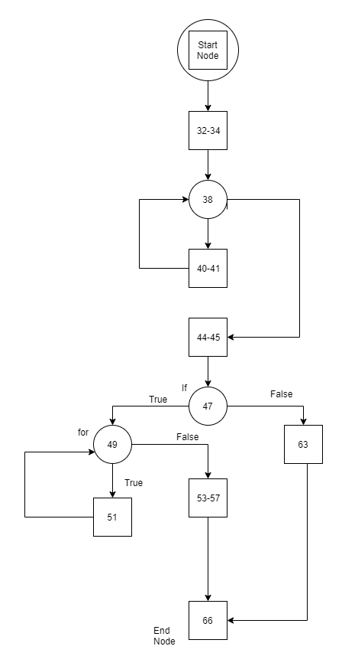

**Main Function Cyclomatic Complexity:**

Number of Edges (e): 13

Number of Node (n): 11

Number of Separate Flow Graphs (C): 1

Cyclomatic Complexity of Main Function = e-n+2C

= 13-11+2*1

= 2+2

= 4

**Stats Function Flowgraph: (separate file also attached)**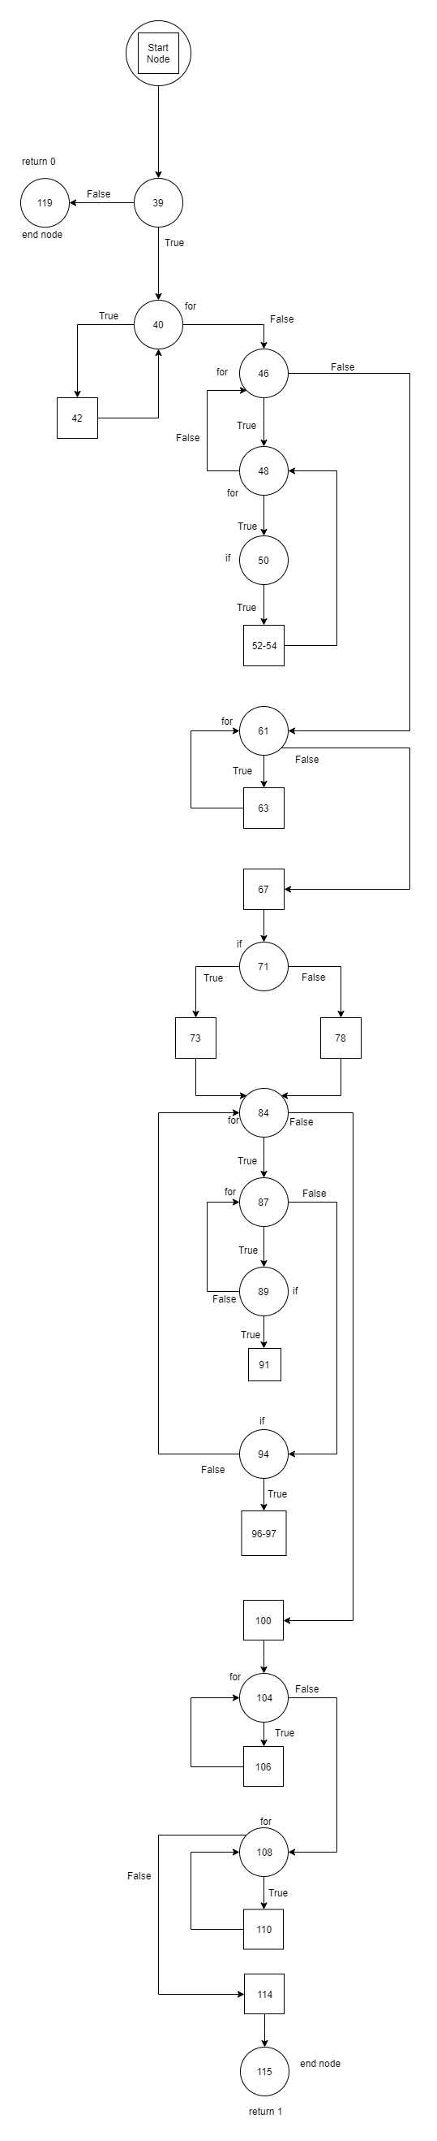

**Stats Function Cyclomatic Complexity:**

Number of Edges (e): 36

Number of Node (n): 28

Number of Separate Flow Graphs (C): 1

Cyclomatic Complexity of Stats Function= e-n+2C

= 36-28+2*1

= 8+2

= 10